

**UNIVERSITY OF PETROLEUM AND ENERGY STUDIES**

**School of Computer** **Science**

**2020-21**

**GRAPHICS AND ANIMATION TOOLS LAB**

**Faculty: Dr. DURGANSH SHARMA**

**Assistant Professor**

**Department of Cybernetics.**

**School of Computer Science, UPES**

**Submitted By:**

**Name- Ishita J Karmakar**

**Roll no-R100217107**

**Batch-B3**

**Semester- 7**

**Course-B.Tech CSE-OSOS**

**SAP ID- 500064067**

**EXPERIMENT NO 8**

**Aim** :- Design a 3D Car using Blender.

**Objective** :- To Design a 3D Car using features of Blender 2.8.

**STEPS TO DESIGN A 3D CAR-**

1. Open Blender workspace select the existing cube and go to edit mode.
2. Delete the half part of the cube and add a mirror modifier to the cube.
3. Download an image of car, Press Shift+A to add an image in the background.
4. No go to X ray mode of the cube. By using extrude and scaling shape the cube as per the image of car.
5. Now take a Bezier circle for the wheel. By extruding and scaling add features to the wheel.

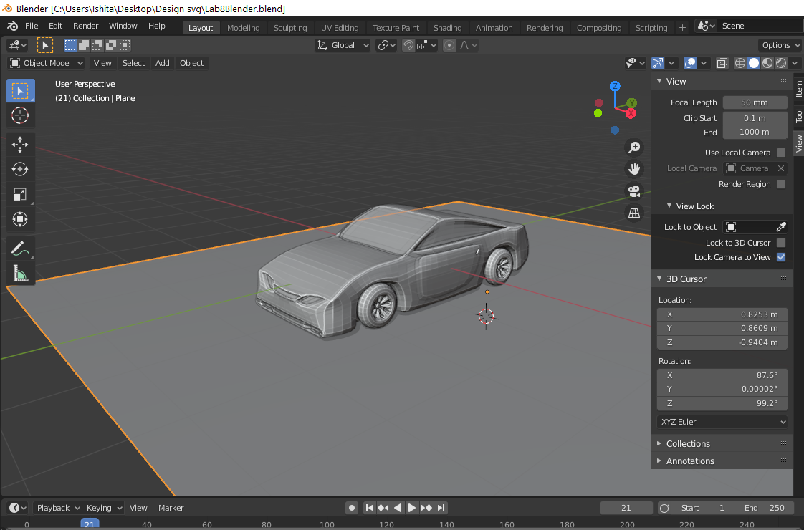

1. At last create three material colors red, light blue with transparency properties(glass) and light blue with emission properties (headlight and backlight). Reduces or increase roughness according to your need.

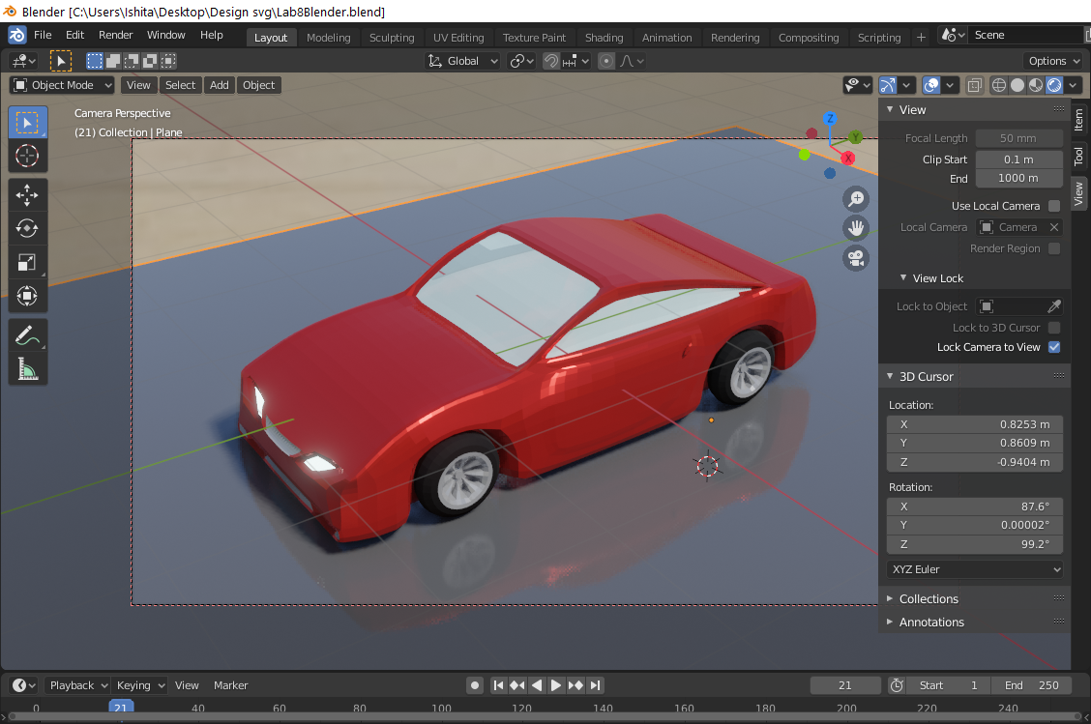

1. Now render the final model.

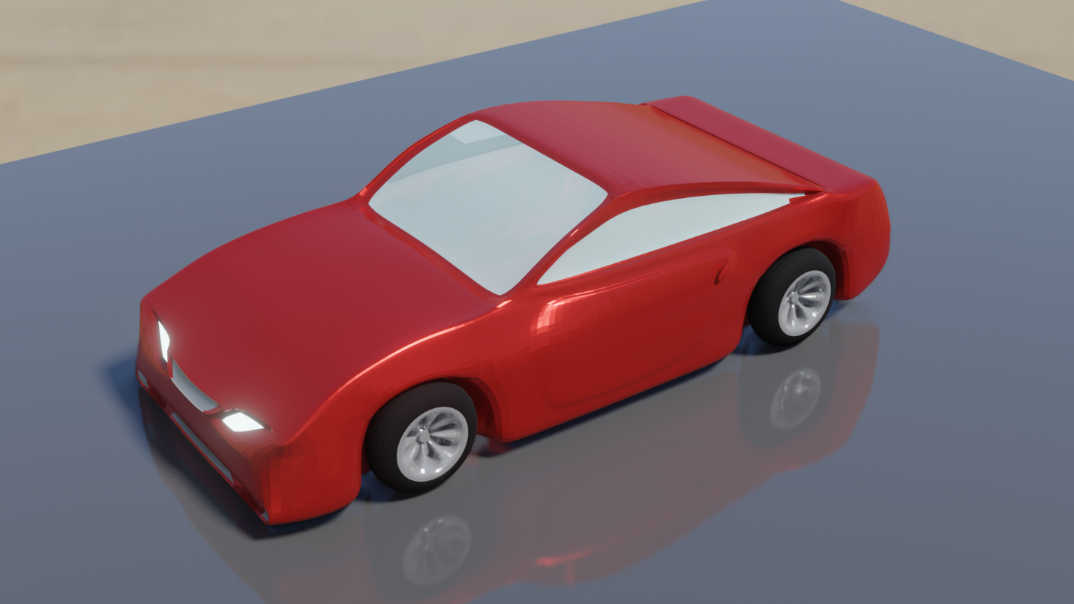

Link for Google Drive: - <https://drive.google.com/drive/folders/1Vc3HCQ204p_QJ5YPvyXDLtTq33J7R8t9?usp=sharing>